I/O Generic Programming, Function and Class Templates Assignments

Mandatory Assignments

1. Write a templated function to add() a maximum of 3 input strings OR 3 integers and return the final string or number. add() function may be called with atleast 2 arguments.

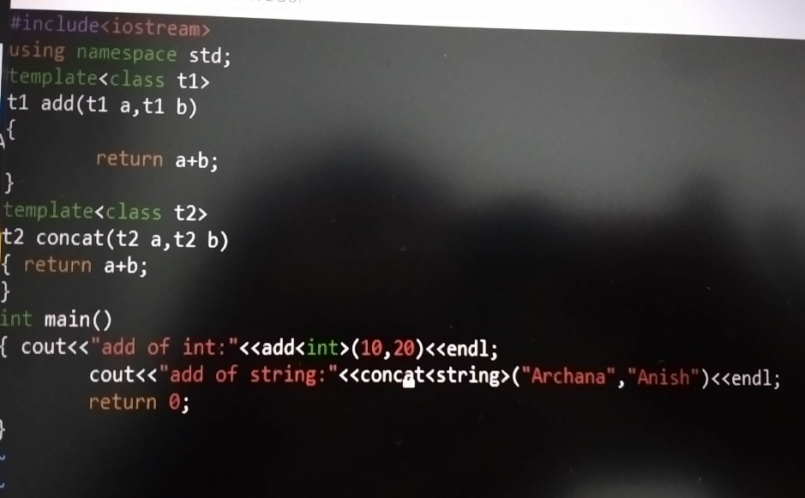

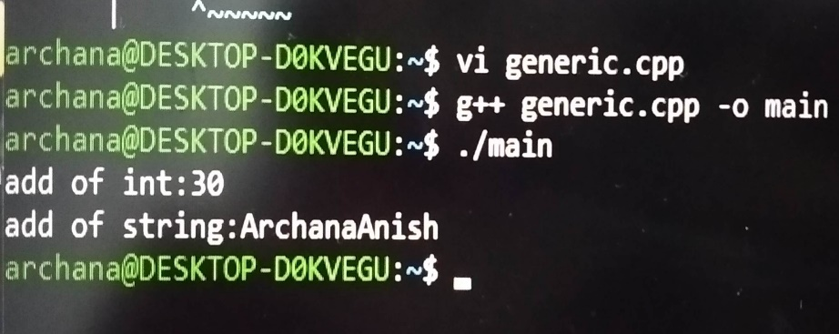

2. Write a templated merge sort function which takes an array of data using merge sort with signature as below. Test with string and float data.

template <class T, int num>

int merge_sort(T arr[], int num> //num is no. of elements in array

{//Add implementation here and return SUCCESS i.e 0}

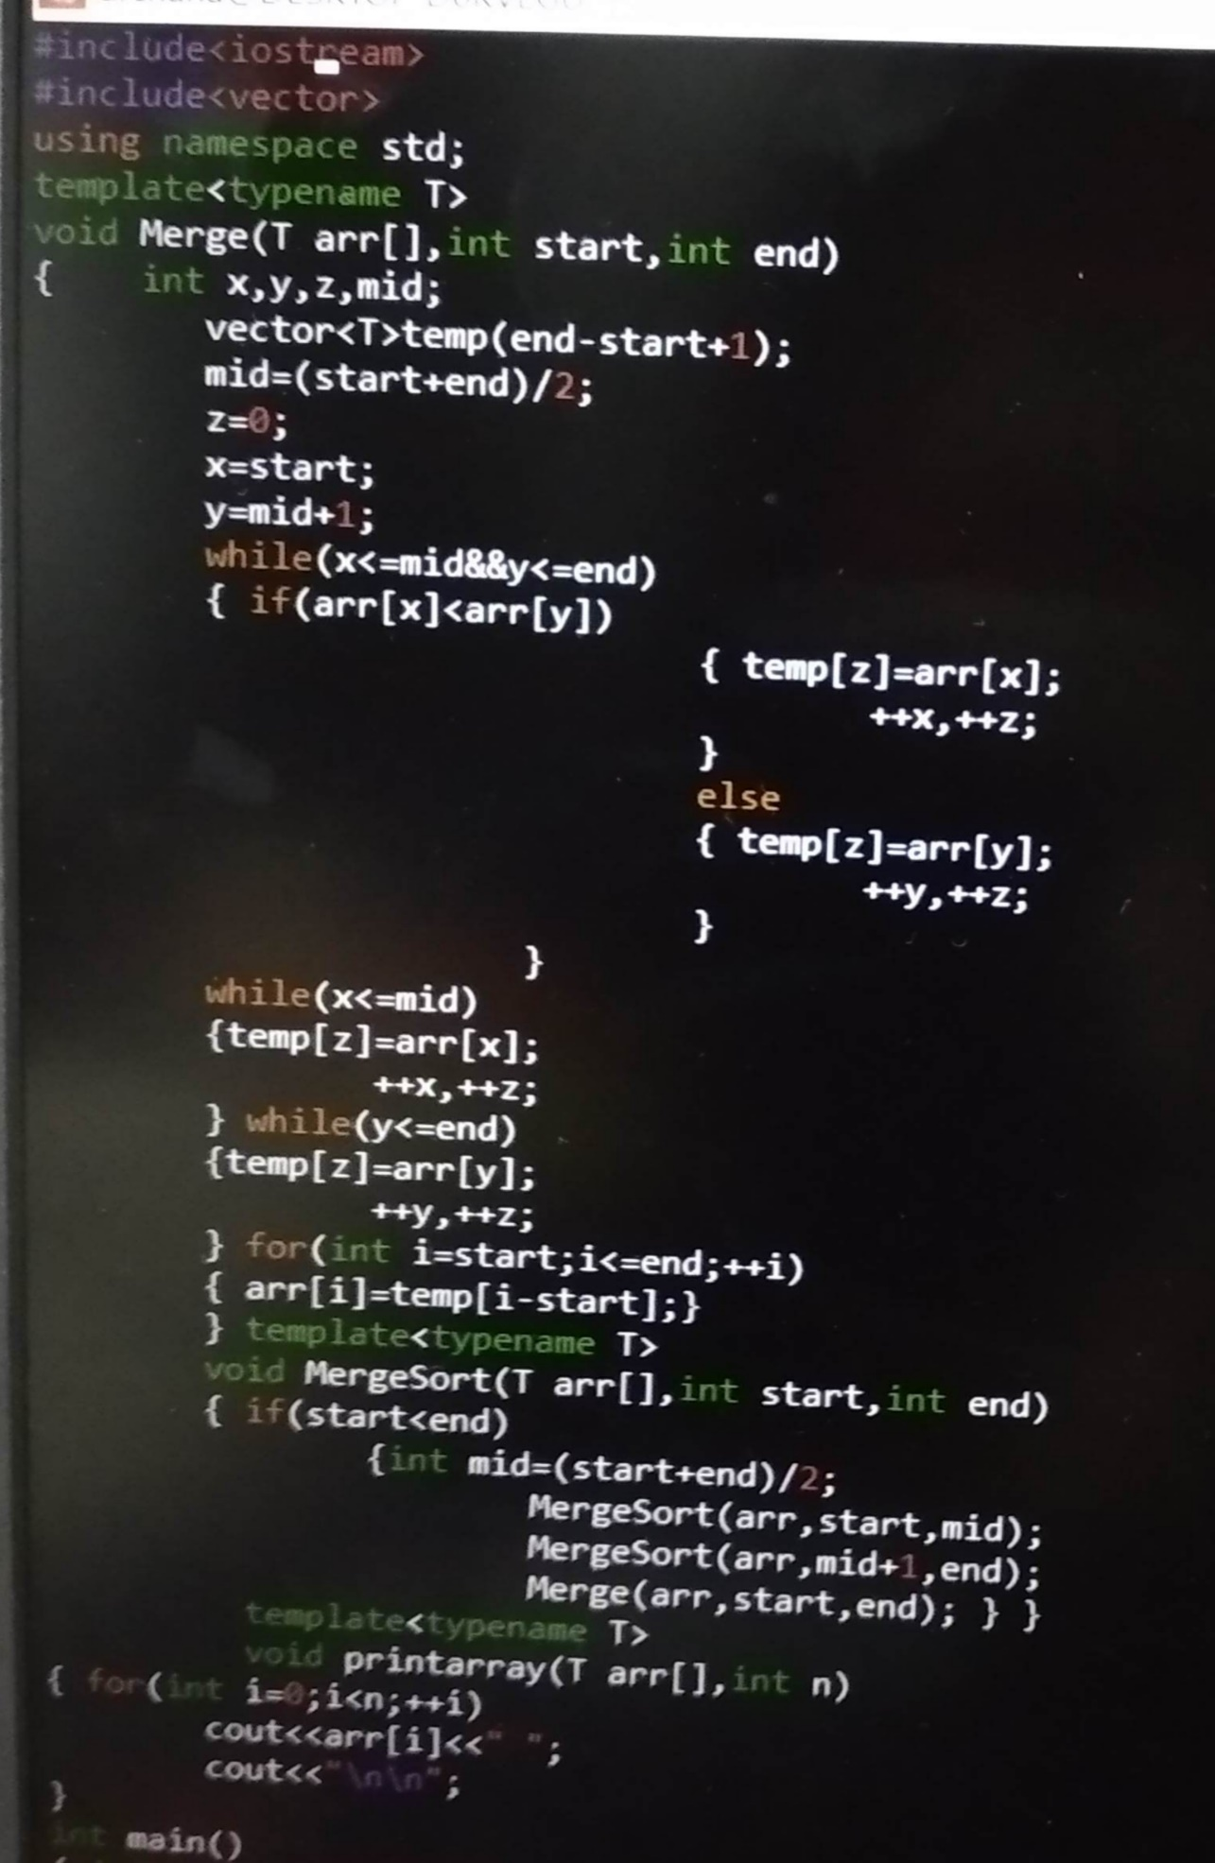

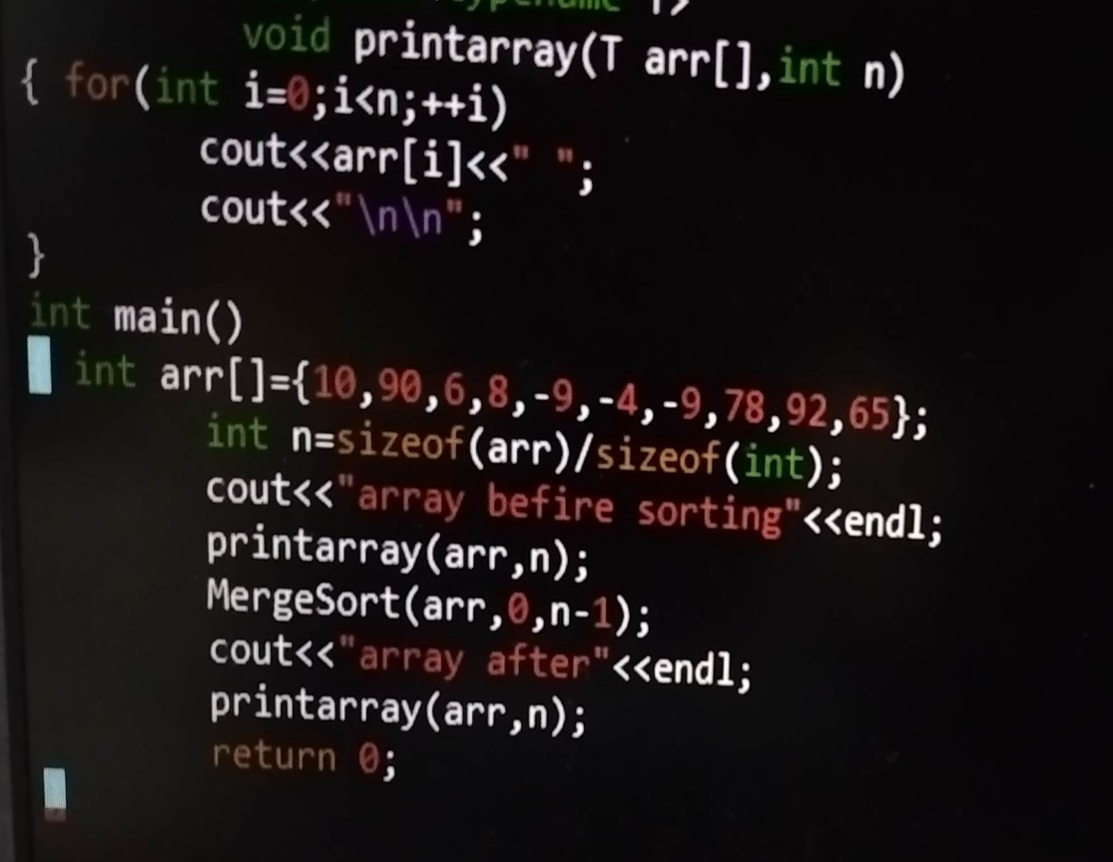

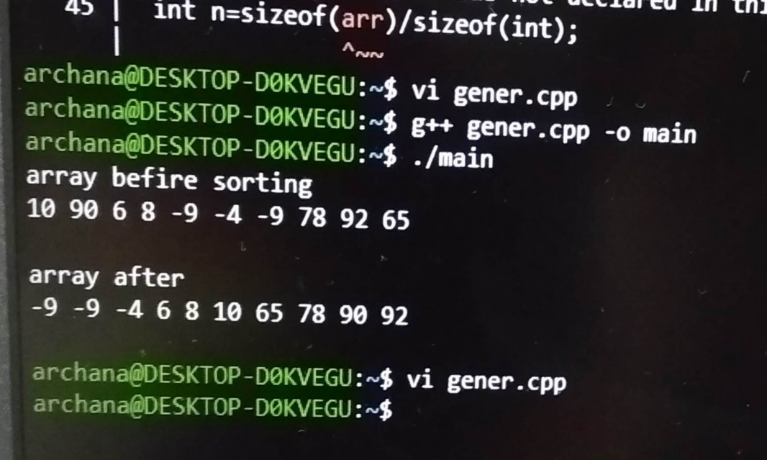

3. Refer the file “function_template_classobj.cpp”. Complete the sections marked with TBD 1..4x to get the expected out as mentioned in the file.

Ø TBD1: Constructor

Ø TBD2: Create object allocating memory from heap, handle exception

Ø TBD3: Implement template function myadd()

Ø TBD4a, b: Deallocate the assigned memory

Verify your output with expected output

4. Create a templated class named “MyArrayClass” with templated 1D array of MAX_ELEMENTS.

a. Populate the array using function below.

// populate MAX_ELEMENTS in the 1D array with input arr content, count = no . of elements in input array

PopulateData(T *arr, int count);

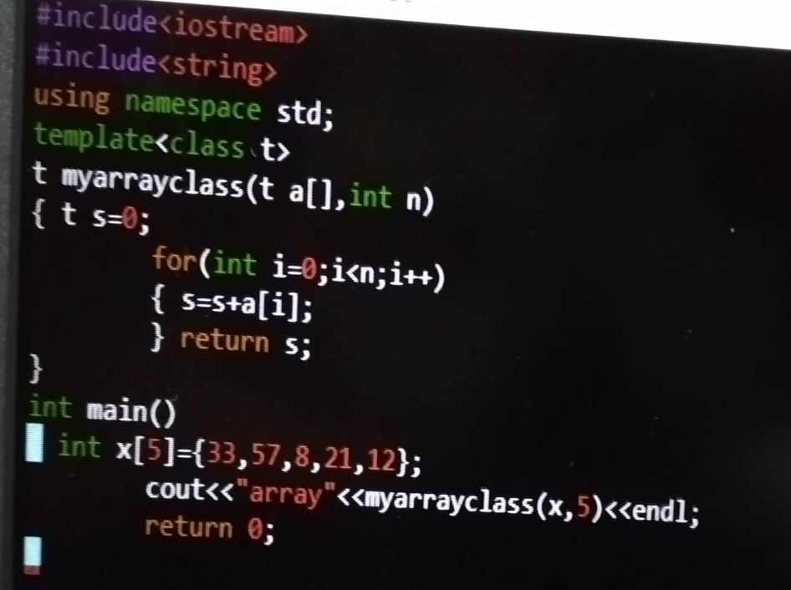

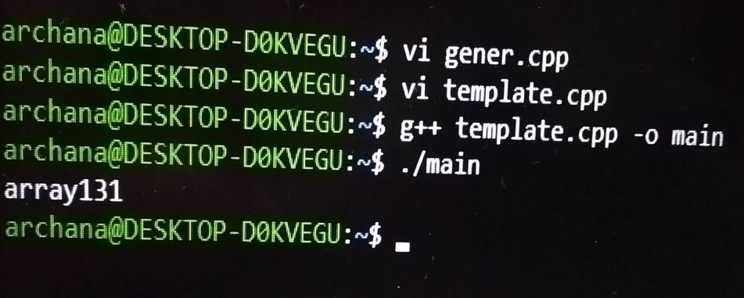

b. For character data provide customized handling i.e convert given character to uppercase and store.

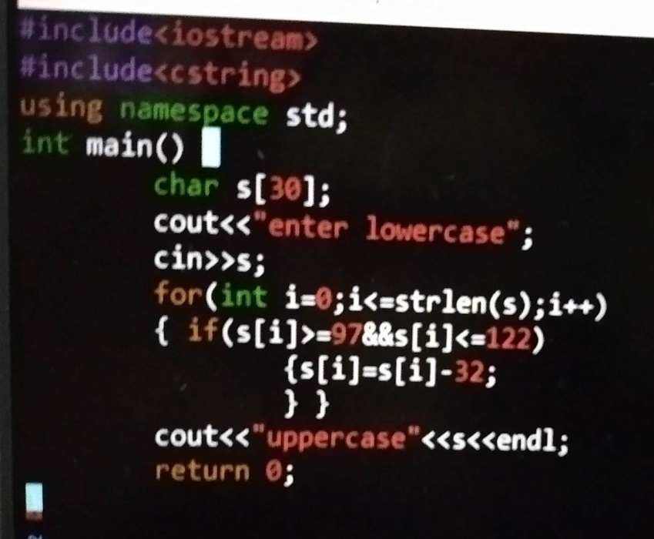

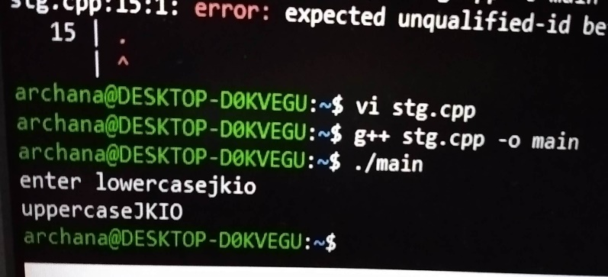

c. Test with int, float and char data.

